**Unit 11, Lesson 4 Review Quiz**

**Multiple Choice**

*Identify the choice that best completes the statement or answers the question.*

**____ 1.** This caddisfly larva lives in a pond. It builds a heavy case for itself of sand, leaves, small sticks, and little shells.

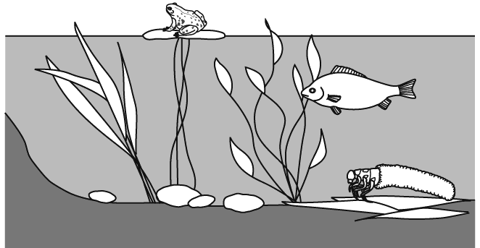

What is the **most likely** advantage of the larva’s case?

|  |  |
| --- | --- |
| **A** | to trap food |
| **B** | to keep it dry |
| **C** | to stay out of the sun |
| **D** | to protect it from predators |

**____ 2.** Trout are fish that live in clear, cold rivers that are rich in oxygen. What do fish use to get oxygen?

|  |  |
| --- | --- |
| **A** | fins |
| **B** | gills |
| **C** | scales |
| **D** | tail |

**____ 3.** Catfish can live in rivers and lakes where the water is not very clear. The following picture shows a catfish.

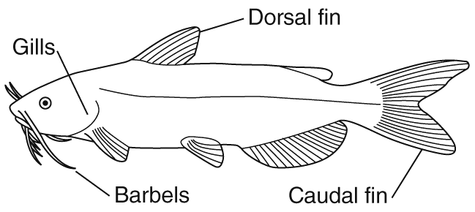

What do the barbels **most likely** help the catfish do in muddy water?

|  |  |
| --- | --- |
| **A** | grab objects |
| **B** | dig holes |
| **C** | sense objects |
| **D** | breathe better |

**____ 4.** A scientist discovered a new bird species. It has a long, pointed beak and long legs without feathers. For which habitat is this bird **most likely** adapted?

|  |  |
| --- | --- |
| **A** | deep oceans with small fish |
| **B** | marshes with tall reeds and small fish |
| **C** | mountain streams with mostly rocks and insects |
| **D** | intertidal zones with large rocks, starfish and clams |

**____ 5.** The picture shows an alligator that lives in the Florida Everglades.

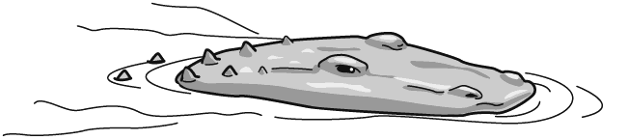

What advantage does this swimming position give the alligator?

|  |  |
| --- | --- |
| **A** | It keeps its skin from drying out. |
| **B** | It keeps it away from muddy water. |
| **C** | It keeps it mostly hidden under water, but and the alligator can still see prey. |
| **D** | It keeps its body temperature from getting too high. |

**____ 6.** The following pictures show four birds.

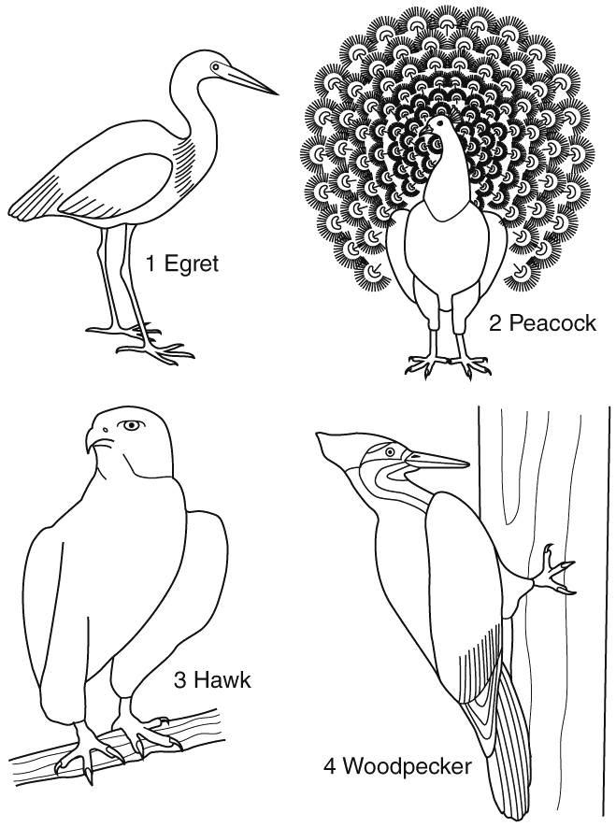

Which bird has a physical characteristic that would be **most** useful in the water of a marshy wetland?

|  |  |
| --- | --- |
| **A** | 1 |
| **B** | 2 |
| **C** | 3 |
| **D** | 4 |

**____ 7.** The Florida bald cypress tree grows in swamps and river floodplains. Which adaptation is **most** important for trees like the bald cypress?

|  |  |
| --- | --- |
| **A** | tall trunks |
| **B** | flat leaves |
| **C** | flood tolerance |
| **D** | thin bark |

**____ 8.** Red mangrove trees grow in the Everglades along shorelines affected by tides. Which adaptation helps mangroves live with ocean water?

|  |  |
| --- | --- |
| **A** | thick bark |
| **B** | aerial roots |
| **C** | small leaves |
| **D** | salt tolerance |

**____ 9.** A sea turtle’s front legs are large flippers. How does this adaptation help a sea turtle live in the open ocean?

|  |  |
| --- | --- |
| **A** | The flippers help the turtle grasp prey. |
| **B** | The flippers help the turtle swim efficiently. |
| **C** | The flippers help the turtle support itself in kelp beds. |
| **D** | The flippers help the turtle lay eggs on land. |

**____ 10.** Sharks can smell very small amounts of substances in ocean water. What does this adaptation **most likely** let sharks do?

|  |  |
| --- | --- |
| **A** | sense water temperature |
| **B** | find a place to lay eggs |
| **C** | find a safe place to hide |
| **D** | find food that is far away |

**____ 11.** Sea otters live in large kelp beds in the open ocean. Otters have very streamlined bodies. What does a streamlined body help an otter do?

|  |  |
| --- | --- |
| **A** | sleep in the kelp bed |
| **B** | swim easily to catch prey |
| **C** | keep water out of its nose |
| **D** | keep its fur dry when it swims |

**Short Answer**

**1.** In the deep ocean, there is no light for producers to use for photosynthesis. One producer in the deep ocean is a bacteria that uses minerals as its energy source. Describe where the minerals come from.

**Unit 11, Lesson 4 Review Quiz**

**Answer Section**

**MULTIPLE CHOICE**

**1.** ANS: D

• A is incorrect. The larva occupies the case and grazes on algae on underwater surfaces.

• B is incorrect because the larva lives underwater.

• C is incorrect because the larva spends its time in the water and out of direct sun.

• D is correct because the larva is more vulnerable to predation if it does not hide in its case.

**2.** ANS: B

• A is incorrect because fish use fins to swim.

• B is correct because fish use gills to take in oxygen.

• C is incorrect because scales are used for protection.

• D is incorrect because fish use tails to swim.

**3.** ANS: C

• A is incorrect because barbels do not serve a grasping function.

• B is incorrect because barbels are used for sensing objects in the water.

• C is correct. Barbels sense chemicals in the water.

• D is incorrect because gills are used for the breathing function.

**4.** ANS: B

• A is incorrect because long legs are not adaptations for swimming in the ocean.

• B is correct because long legs blend with reeds in marshes, and pointed beaks would be useful for spearing fish.

• C is incorrect because long legs don’t blend in with mossy rocks.

• D is incorrect because a long, pointed beak is not adapted for eating starfish and clams.

**5.** ANS: C

• A is incorrect. Scaly skin does not dry out. This position helps the alligator hunt.

• B is incorrect because the position helps the alligator hunt.

• C is correct because the position helps the alligator see prey in the water or on the bank.

• D is incorrect. Although water would keep the alligator cool, this swimming position helps the alligator hunt.

**6.** ANS: A

• A is correct because long legs help the egret walk about in a wetland that has varying water depth.

• B is incorrect because the peacock’s large tail would be a disadvantage in a wetland environment.

• C is incorrect because although hawks prey on fish, they do not live in the water.

• D is incorrect because the woodpecker’s bill helps it drill into tree trunks to find insects to eat.

**7.** ANS: C

• A is incorrect because tolerance of being wet is most important for living where the ground is often flooded.

• B is incorrect because flat leaves are present in trees of many habitats.

• C is correct because water levels in floodplains fluctuate regularly, and trees that could not tolerate the changes would not be able to live there.

• D is incorrect because thin bark is present in trees of many habitats.

**8.** ANS: D

• A is incorrect because salt tolerance, not thick bark, is the tree’s most important adaptation to tide water.

• B is incorrect. Aerial roots support the tree and collect sediment but are not as important as salt tolerance in ocean water.

• C is incorrect because salt tolerance is more important than small leaves. Many kinds of trees have small leaves.

• D is correct because a tree that could not tolerate salt water could not live in a tidal area.

**9.** ANS: B

• A is incorrect because turtles use their mouths, not their flippers, to grasp food.

• B is correct because large flippers are better for swimming than legs would be.

• C is incorrect. Baby turtles do live in kelp beds, but flippers are most useful for swimming.

• D is incorrect. Turtles can walk on land, but flippers are much better suited to swimming.

**10.** ANS: D

• A is incorrect. Sharks use their sense of smell to detect food.

• B is incorrect because sharks use their sense of smell to detect food.

• C is incorrect because large sharks do not hide.

• D is correct because the shark’s keen sense of smell allows it to smell a small amount of a substance even at great distances.

**11.** ANS: B

• A is incorrect because otters wrap themselves up in the kelp before they sleep.

• B is correct because a streamlined body is best for swimming.

• C is incorrect because otters can close their nostrils when they dive.

• D is incorrect because otters spend a lot of time grooming to keep their fur dry.

**SHORT ANSWER**

**1.** ANS:

Sample answer: The minerals come from ocean vents. Ocean vents are hot places on the ocean floor where water warmed by Earth’s interior exits back into the ocean. These bacteria use minerals to make food.

Students’ answers should include:

• understanding that minerals come from vents on the ocean floor

• understanding that the ocean vents are the outlets for hot water and minerals that are heating from deep within Earth